# What Is Six Sigma Certification?

Six Sigma certification is a confirmation of an individual’s capabilities with respect to specific competencies. Just like any other quality certification, however, it does not indicate that an individual is capable of unlimited process improvement – just that they have completed the necessary requirements from the company granting the certification

# Should I Get Six Sigma Certified?

The reasons for certification are the same for any other certification:

* to display proficiency in the subject matter
* to increase desirability by employers
* to potentially increase your salary

Ultimately, certification is a professional decision that can only be made by you. In some cases, it will be required for you to advance within an organization. For instance, at some companies it is a requirement of every salaried employee to be Green Belt trained and certified if they want to be promoted within the organization. In other cases, Six Sigma certification will display your energy and intent to be a leader within the quality profession.

# How to Get Six Sigma Certified

Instructions:

*1.* Determine which level of Six Sigma certification you are seeking. Both Green Belt and Black Belt certifications are available, with the latter requiring a greater commitment and level of skill.

*2.* Obtain Six Sigma training. If you have not yet completed a training program for the level of certification you are seeking, you will need to devote substantial time and effort to learning Six Sigma methodology, project management techniques and data analysis tools.

[ACCA Course in London](http://www.googleadservices.com/pagead/aclk?sa=L&ai=C_6YZeEFWUvvAF4e4ige8s4CYBpDxhOUDyI7czmeQn6C6TRABIKmJrQZQ8JPOkwZgwbX6DaABgNHh1QPIAQGpAoIS3lblv7o-qAMBqgSOAU_QpL9af71QObu5AafiSuK7W3LFkaw3lVxFvLQ2lZzFk23nJTEyQQnBRpOCzUK8lp3ytjAXeGlzIL9PLBY3zhot9A1avVDHSLWfgF2050IqiEU-65NXAR1ZFle0wkEDW0SWHrDvXZswqGtj1UzSx9g8w0SgkQSevxik9vw6nNAlWM3FitiBTDULKfNRKvCIBgGAB-iunio&num=1&cid=5Gj9AfFcPrVgW1utNM62hE82&sig=AOD64_0Od9ur1omLsvbEDzVgi3xzksOT1A&client=ca-ehow_300x250&adurl=http://www.lsbf.org.uk/acca.html%3Futm_source%3Dgoogle%26utm_medium%3Dcpc%26utm_campaign%3Dacca-vietnam-display-text)

Learn from Award-winning Tutors! Free Financial Skills Certificates.

[www.LSBF.org.uk/ACCA](http://www.googleadservices.com/pagead/aclk?sa=L&ai=C_6YZeEFWUvvAF4e4ige8s4CYBpDxhOUDyI7czmeQn6C6TRABIKmJrQZQ8JPOkwZgwbX6DaABgNHh1QPIAQGpAoIS3lblv7o-qAMBqgSOAU_QpL9af71QObu5AafiSuK7W3LFkaw3lVxFvLQ2lZzFk23nJTEyQQnBRpOCzUK8lp3ytjAXeGlzIL9PLBY3zhot9A1avVDHSLWfgF2050IqiEU-65NXAR1ZFle0wkEDW0SWHrDvXZswqGtj1UzSx9g8w0SgkQSevxik9vw6nNAlWM3FitiBTDULKfNRKvCIBgGAB-iunio&num=1&cid=5Gj9AfFcPrVgW1utNM62hE82&sig=AOD64_0Od9ur1omLsvbEDzVgi3xzksOT1A&client=ca-ehow_300x250&adurl=http://www.lsbf.org.uk/acca.html%3Futm_source%3Dgoogle%26utm_medium%3Dcpc%26utm_campaign%3Dacca-vietnam-display-text)

*3.* Complete one or more successful Six Sigma projects using the information and skills you have learned. You may be able to do this within your place of employment, or you may need to work in the capacity of a consultant or intern for another organization.

*4.* Select a certifying agency and submit your application. Be sure that you review the requirements for certification and are prepared to meet them.

*5.* Take the certification examination. Almost any certifying body will require that you pass a written test as part of the certification process.

*6.* Submit proof of your successfully completed projects. Unless you are getting certified by the same organization through which you were trained, you will be expected to submit an affidavit showing that you meet the project completion requirements.

# Mechanism of six sigma certifications

**Lean Six Sigma** is a process improvements philosophy used by companies worldwide. General Electric and Motorola developed a certification program as part of their training and implementation of Six Sigma, by verifying individual skill level as belts.

Six Sigma professionals exist at every level – each with a different role to play. While implementations and roles may vary, here is a basic guide to who does what.

At the project level, there are black belts, master black belts, green belts, yellow belts and white belts. These people conduct projects and implement improvements.

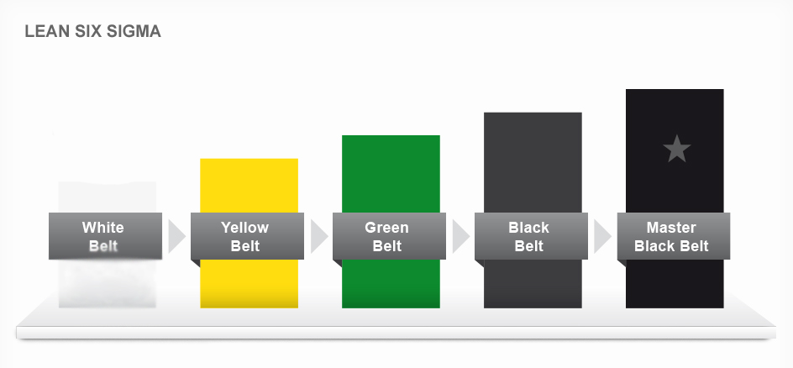

* White Belt: Can work on local problem-solving teams that support overall projects, but may not be part of a Six Sigma project team. Understands basic Six Sigma concepts from an awareness perspective.
* Yellow Belt: Participates as a project team member. Reviews process improvements that support the project.
* Green Belt: Assists with data collection and analysis for Black Belt projects. Leads Green Belt projects or teams.
* Black Belt: Leads problem-solving projects. Trains and coaches project teams.
* Master Black Belt: Trains and coaches Black Belts and Green Belts. Functions more at the Six Sigma program level by developing key metrics and the strategic direction. Acts as an organization’s Six Sigma technologist and internal consultant.

In addition, very project needs organizational support. Six Sigma executives and champions set the direction for selecting and deploying projects. They ensure, at a high level, that projects succeed, add value and fit within the organizational plan.

* Champions: Translate the company’s vision, mission, goals and metrics to create an organizational deployment plan and identify individual projects. Identify resources and remove roadblocks.
* Executives: Provide overall alignment by establishing the strategic focus of the Six Sigma program within the context of the organization’s culture and vision.

Read more:

1,2 - <http://www.isixsigma.com/training/certification-articles/what-six-sigma-certification/>

3 - <http://www.ehow.com/how_4815908_six-sigma-certified.html#ixzz2hIPERzFe>

4 - <http://asq.org/learn-about-quality/six-sigma/overview/belts-executives-champions.html>

6sigma online: <http://www.sixsigmaonline.org/SSO_Brochure.pdf>